Metrics are not computable for img011001.jpg with bg_tresh: 0.75

ID 0: (1736, 445)

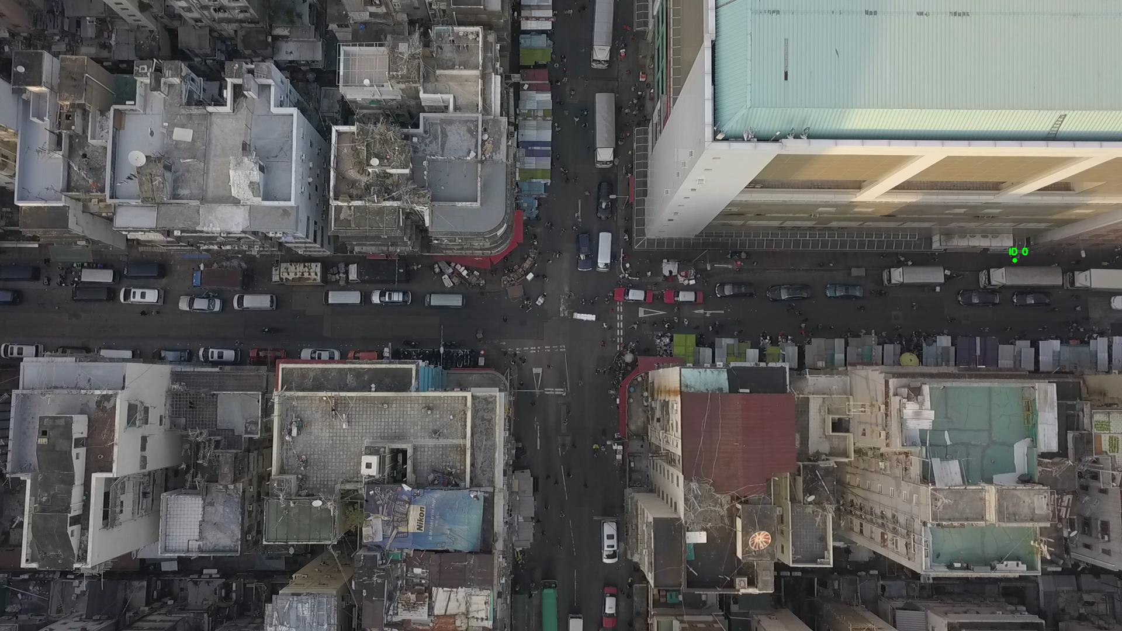

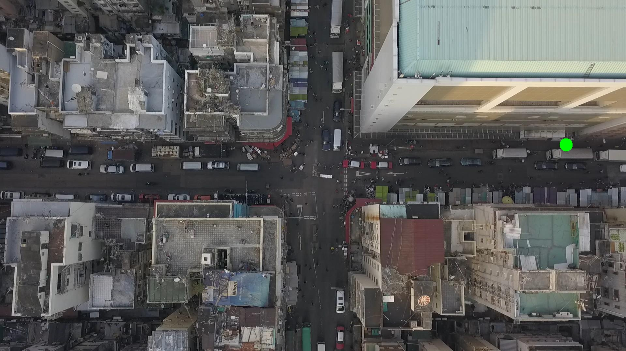

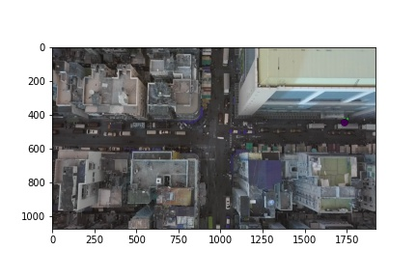

Metrics are not computable for img011002.jpg with bg_tresh: 0.75

ID 0: (1088, 178)

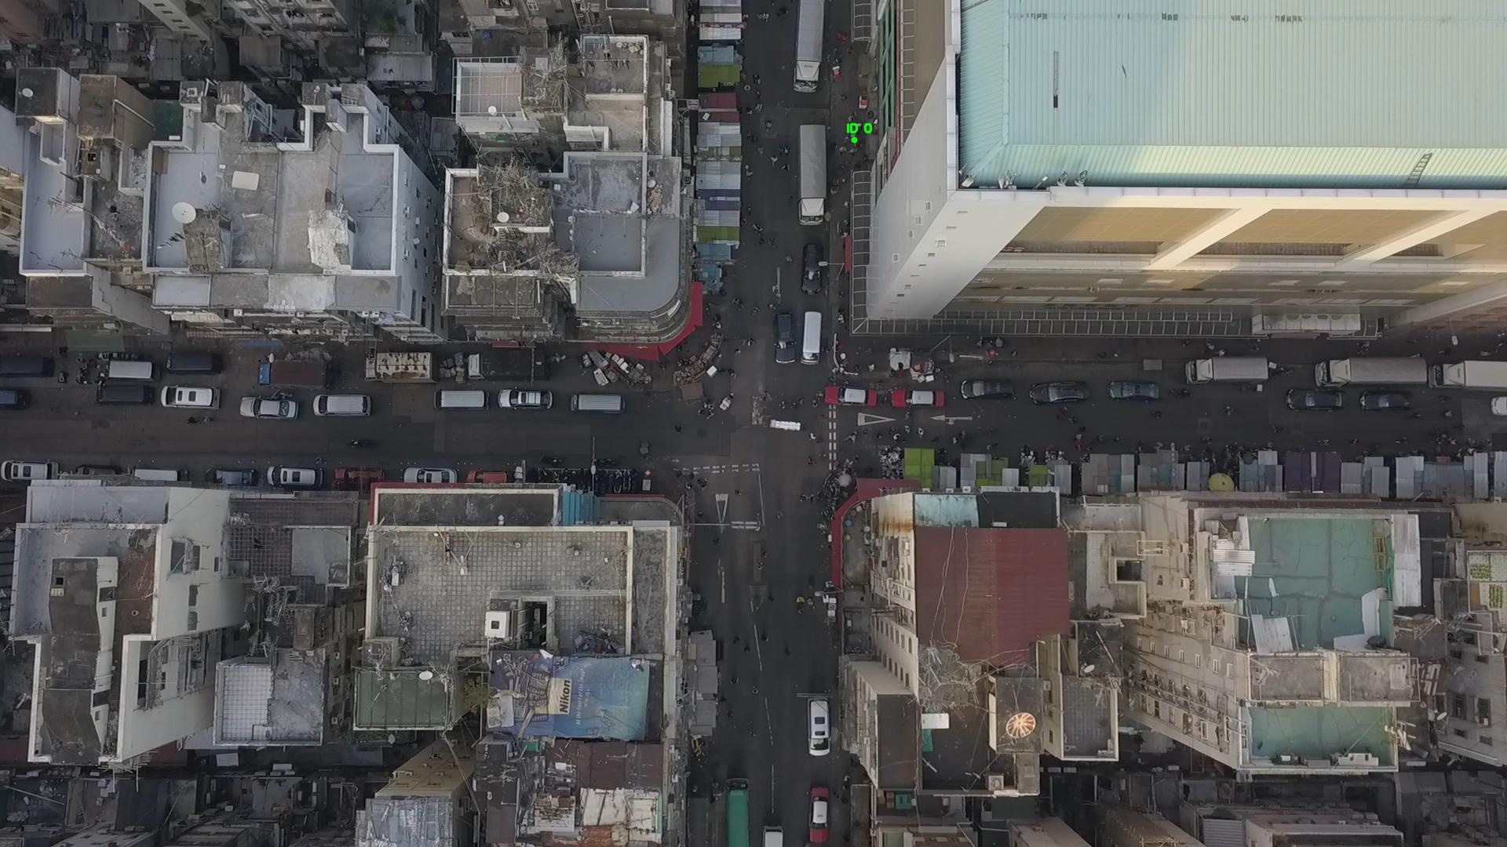

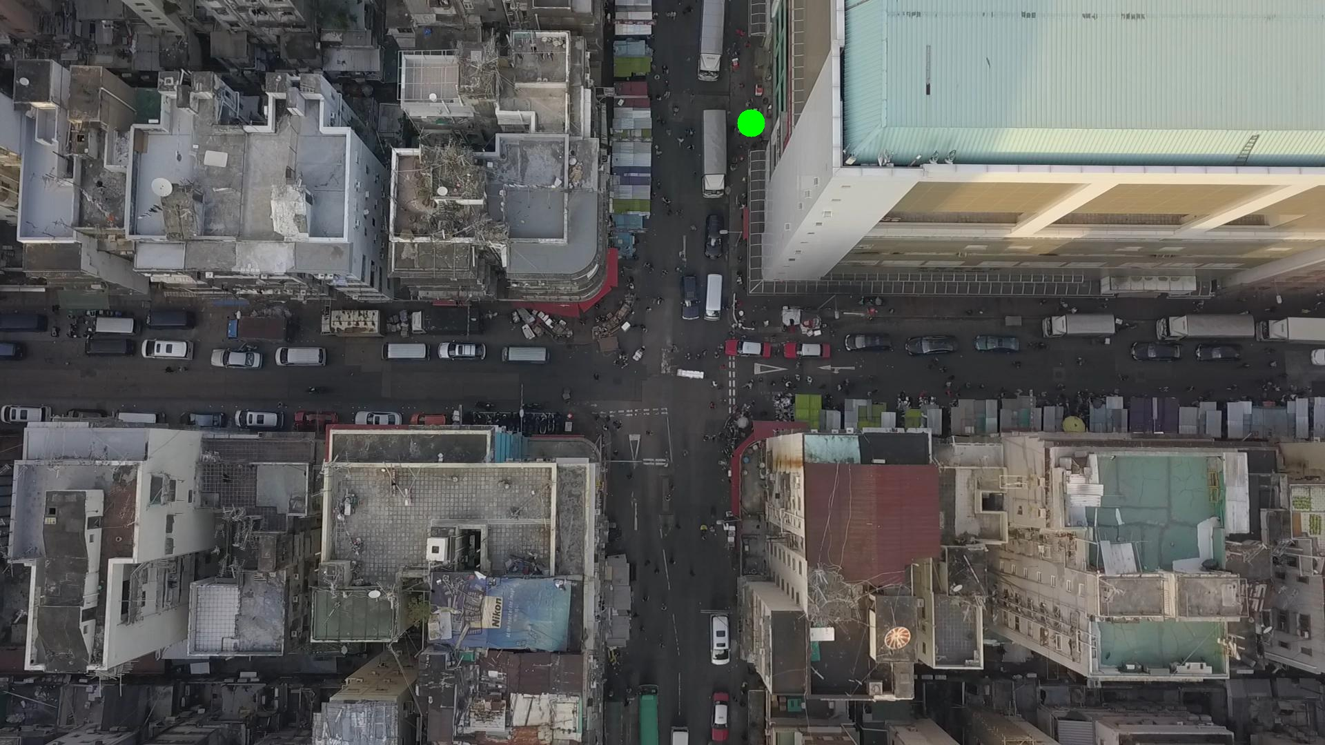

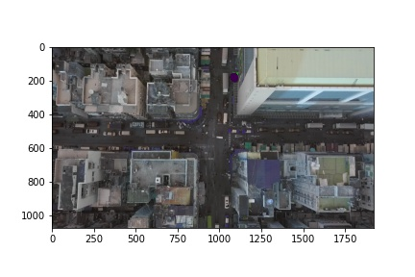

Metrics are not computable for img011003.jpg with bg_tresh: 0.75

ID 0: (1088, 180)

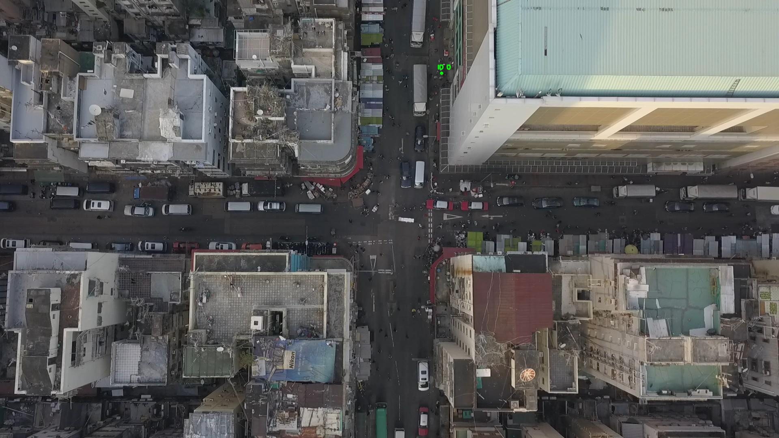

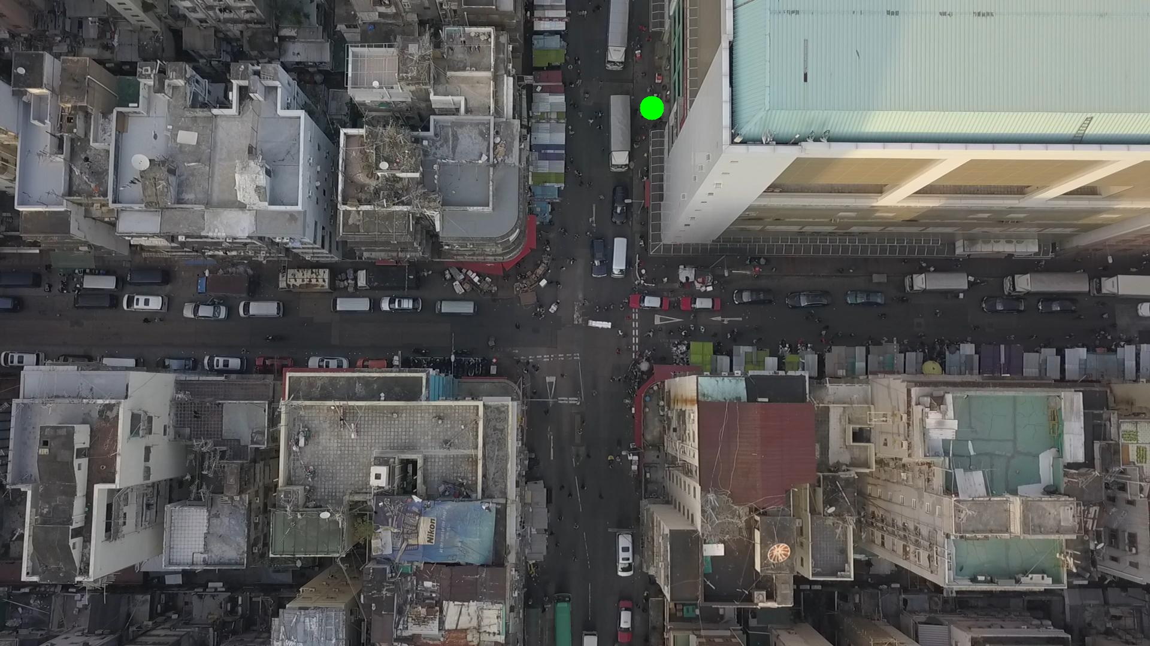

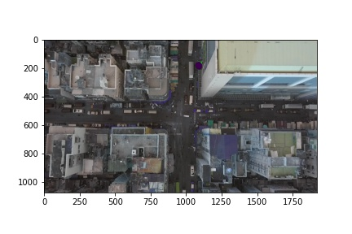

Metrics are not computable for img011004.jpg with bg_tresh: 0.75

ID 0: (1089, 184)

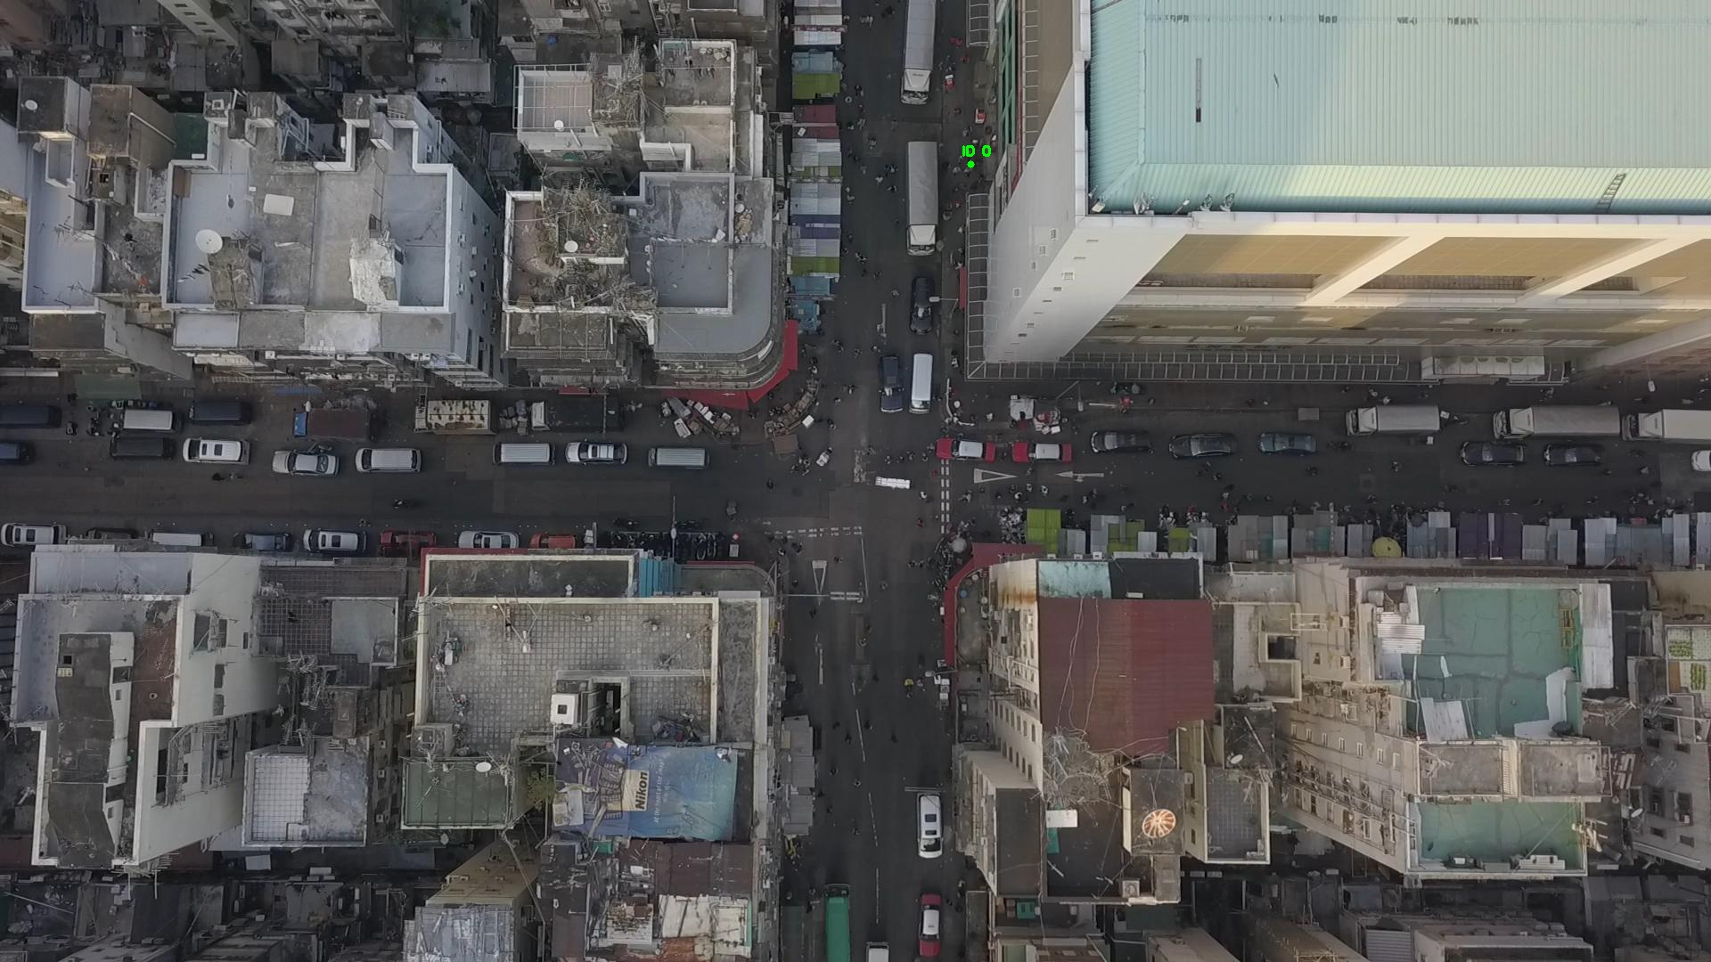

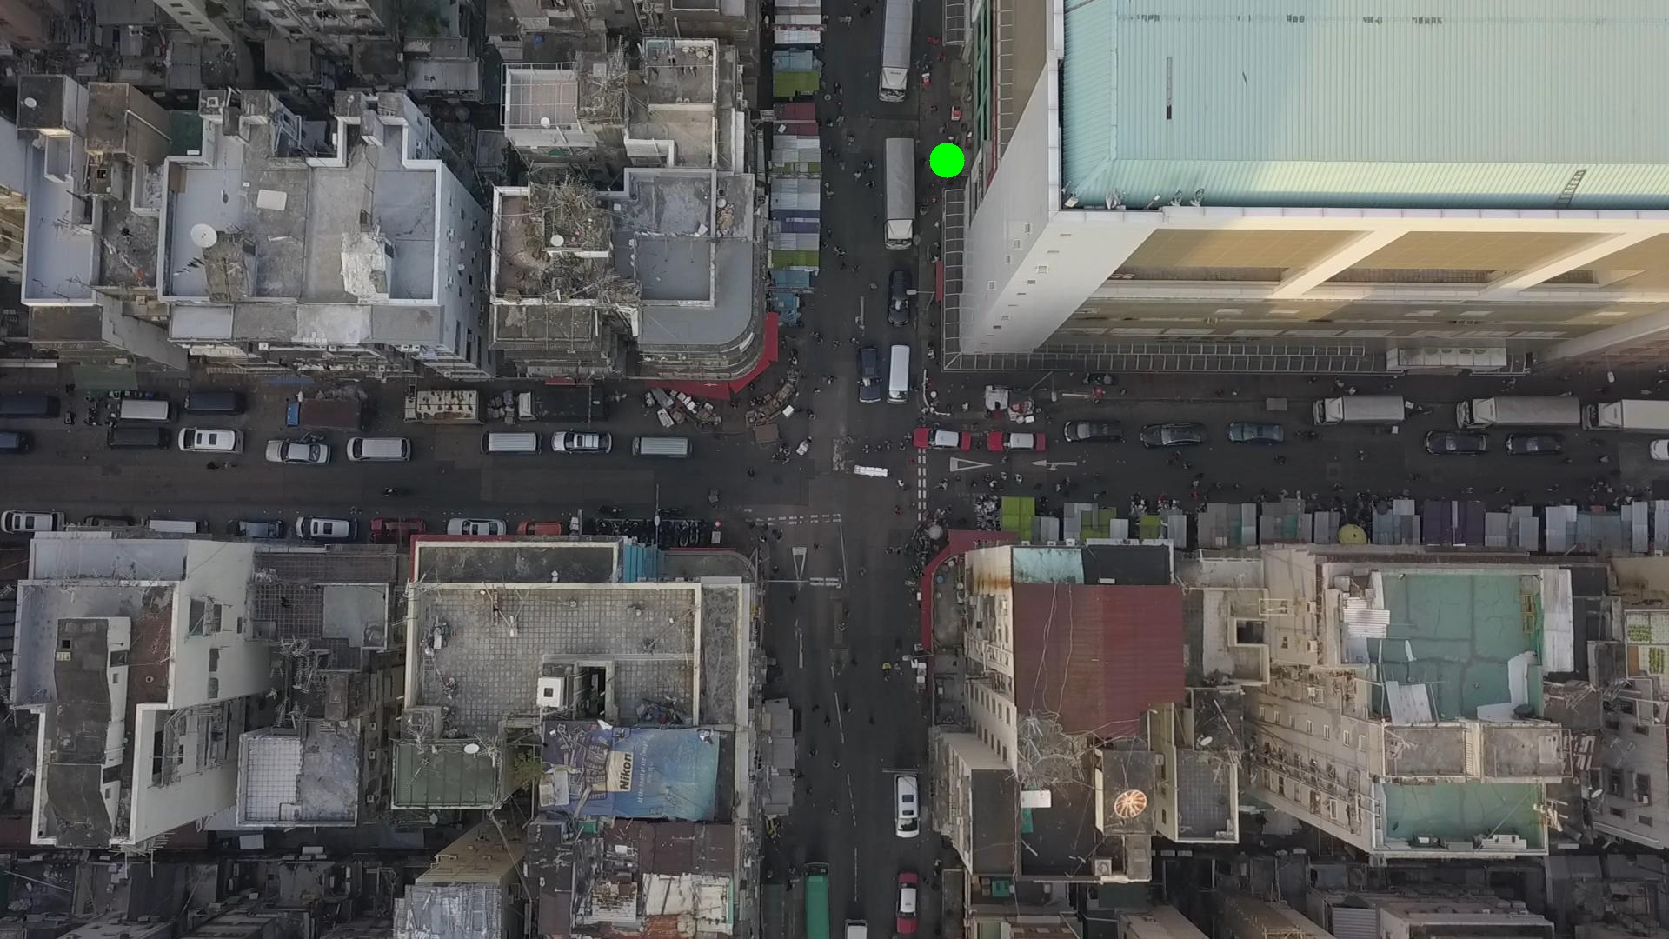

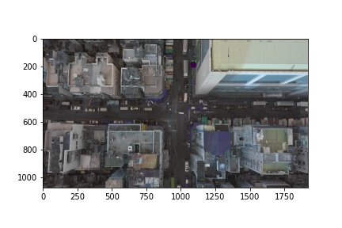

Silhouette metric for img011005.jpg is: 0.9855662615764618

Davies Bouldin metric for img011005.jpg is: 0.012105284143675453

Calinski Harabasz metric for img011005.jpg is: 13907.315075733368

ID 0: (1086, 180)

ID 1: (1142, 557)

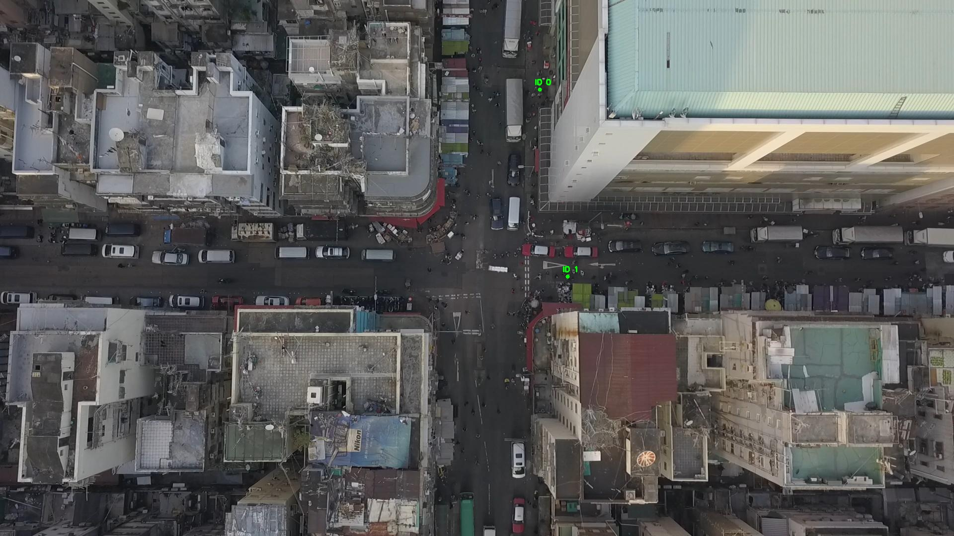

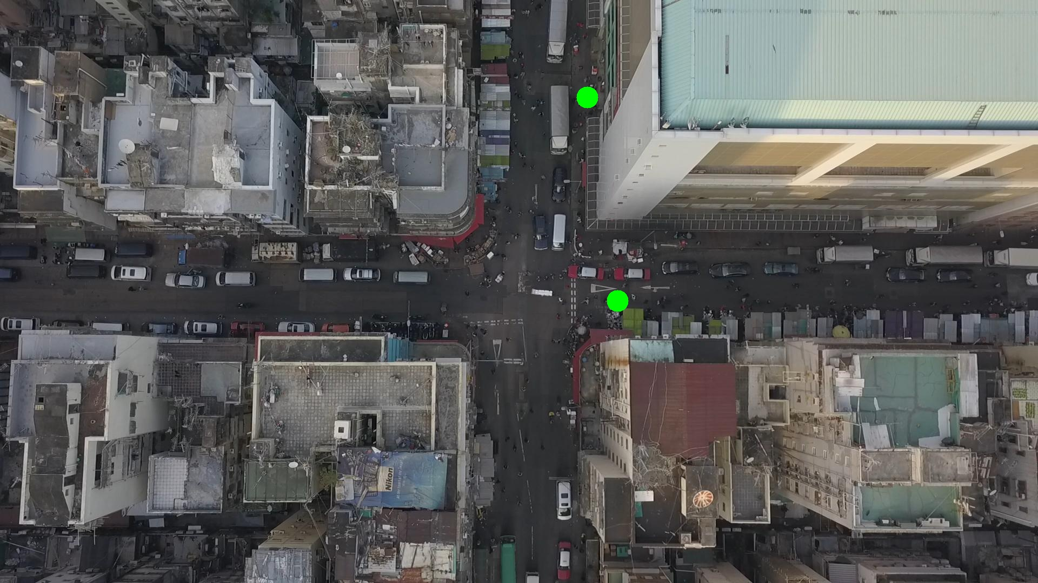

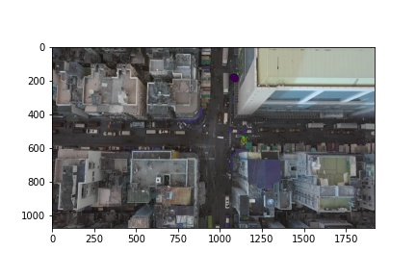

Silhouette metric for img011006.jpg is: 0.8291626773867938

Davies Bouldin metric for img011006.jpg is: 0.17575822955874773

Calinski Harabasz metric for img011006.jpg is: 2974.3445892780906

ID 0: (1085, 190)

ID 1: (1142, 558)

ID 2: (905, 421)

ID 3: (966, 289)

ID 4: (1000, 191)

ID 5: (1376, 553)

ID 6: (890, 654)

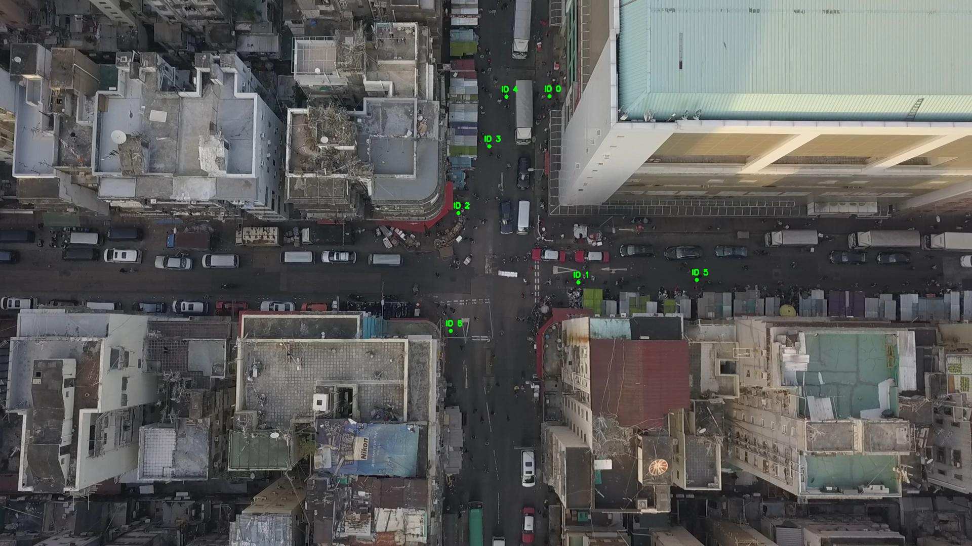

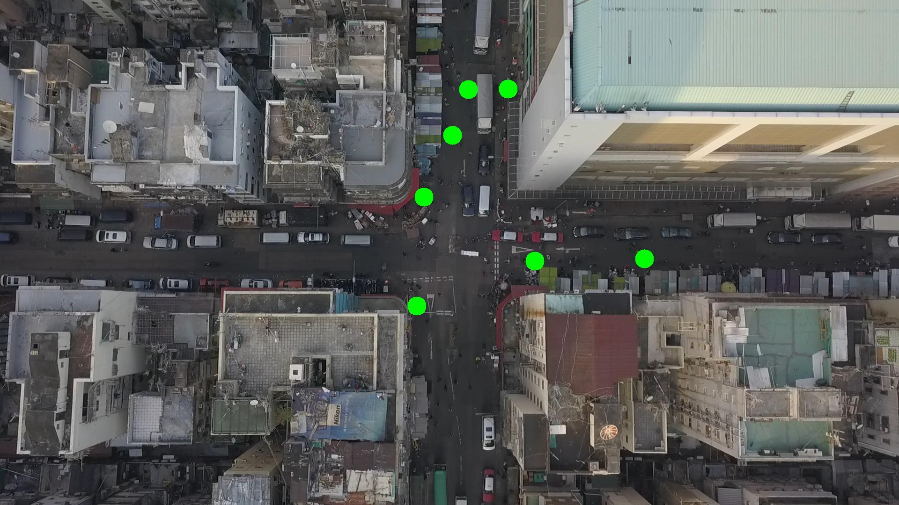

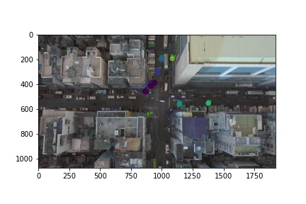

Silhouette metric for img011007.jpg is: 0.8726483585361456

Davies Bouldin metric for img011007.jpg is: 0.12367015539452804

Calinski Harabasz metric for img011007.jpg is: 7870.619849883097

ID 0: (1085, 190)

ID 1: (1142, 558)

ID 2: (925, 387)

ID 3: (965, 285)

ID 4: (1000, 191)

ID 5: (1376, 553)

ID 6: (891, 653)

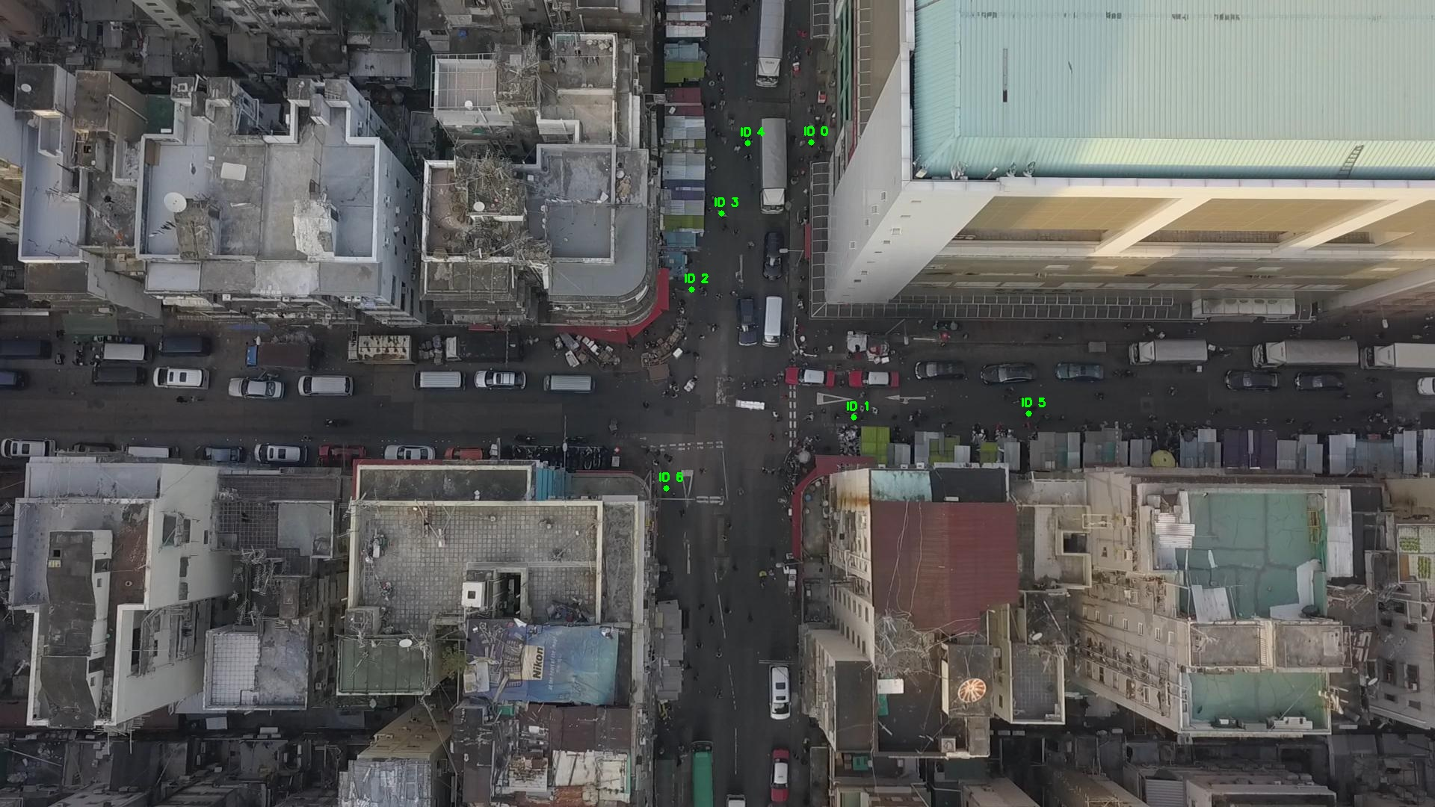

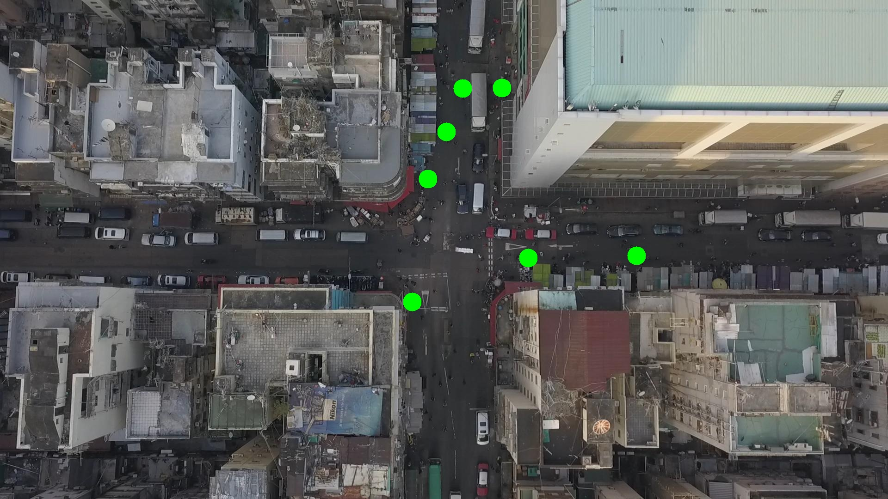

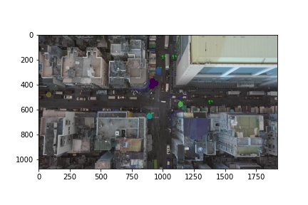

Silhouette metric for img011008.jpg is: 0.9414578095245563

Davies Bouldin metric for img011008.jpg is: 0.06689673142595538

Calinski Harabasz metric for img011008.jpg is: 34959.10554243018

ID 0: (1082, 179)

ID 1: (1138, 560)

ID 2: (936, 385)

ID 3: (966, 284)

ID 4: (1000, 191)

ID 5: (1376, 553)

ID 6: (891, 653)

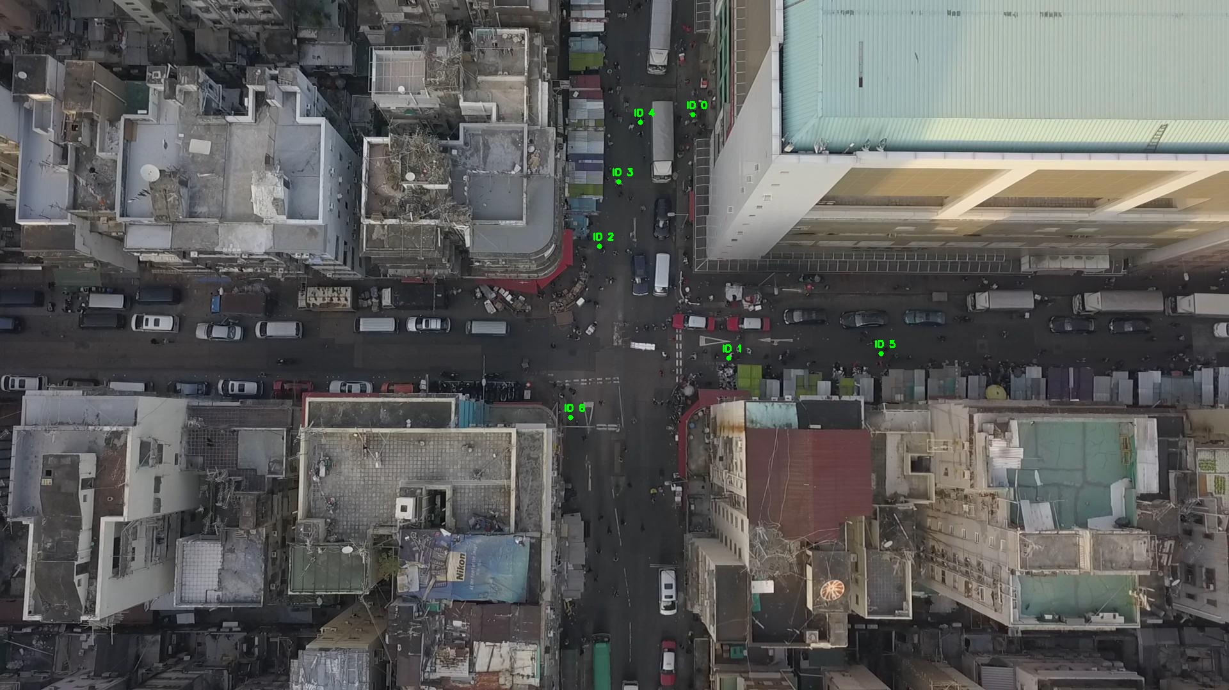

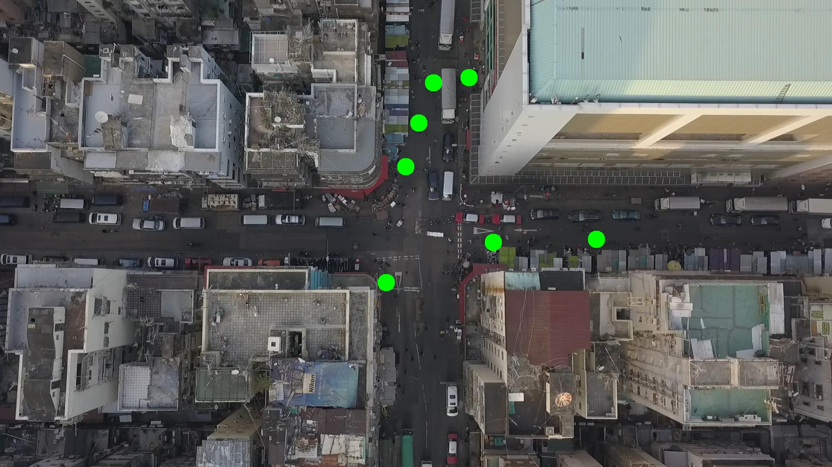

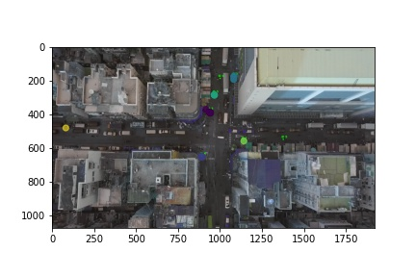

Silhouette metric for img011009.jpg is: 0.9206152628989183

Davies Bouldin metric for img011009.jpg is: 0.10427910445380374

Calinski Harabasz metric for img011009.jpg is: 34388.76346835946

ID 0: (1082, 179)

ID 1: (1142, 580)

ID 2: (935, 390)

ID 3: (966, 287)

ID 4: (1000, 191)

ID 5: (1376, 553)

ID 6: (891, 653)

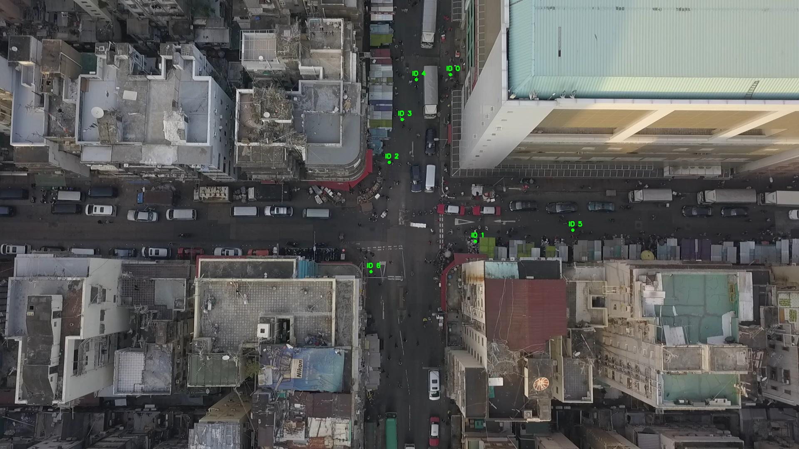

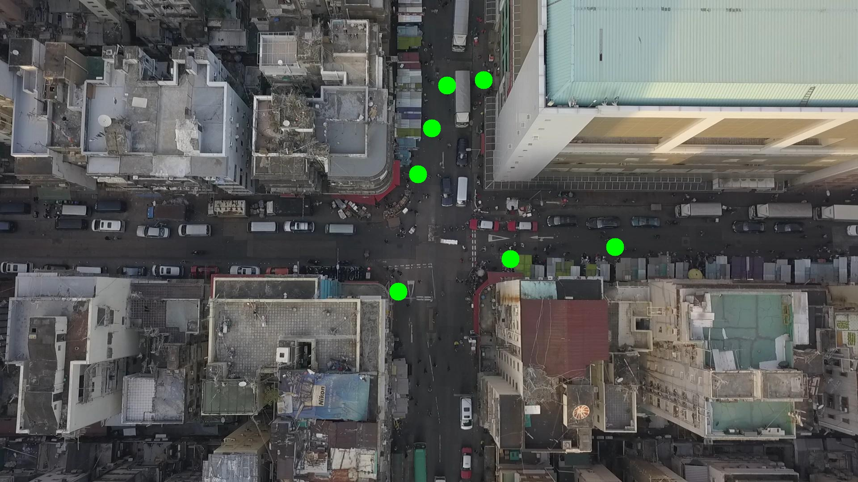

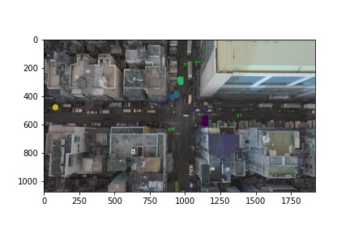

Silhouette metric for img011010.jpg is: 0.9493915074103642

Davies Bouldin metric for img011010.jpg is: 0.05843399897439597

Calinski Harabasz metric for img011010.jpg is: 17779.82277976614

ID 0: (1082, 179)

ID 1: (1140, 572)

ID 2: (939, 389)

ID 3: (966, 287)

ID 4: (1000, 191)

ID 5: (1376, 553)

ID 6: (891, 653)

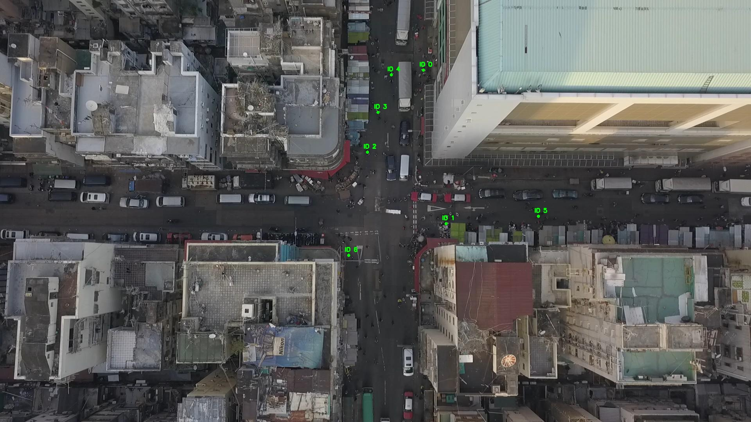

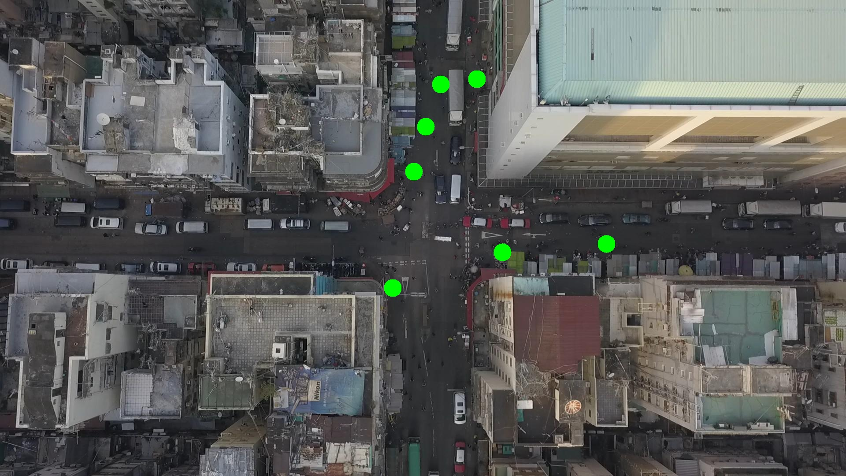

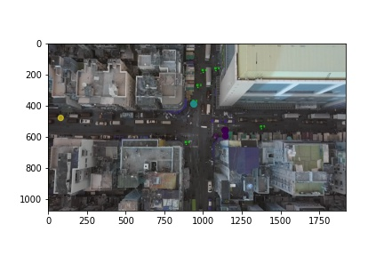

Silhouette metric for img011011.jpg is: 0.912898865349919

Davies Bouldin metric for img011011.jpg is: 0.09185921015490339

Calinski Harabasz metric for img011011.jpg is: 10595.809805433111

ID 0: (1073, 197)

ID 1: (1138, 559)

ID 2: (929, 394)

ID 3: (966, 284)

ID 4: (1000, 191)

ID 5: (1376, 553)

ID 6: (891, 653)

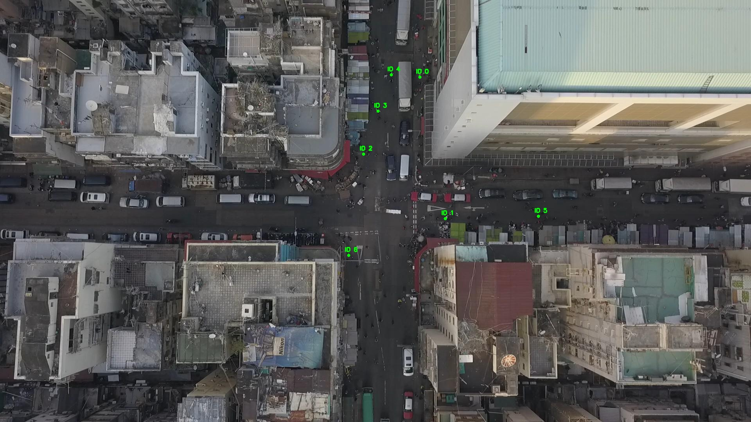

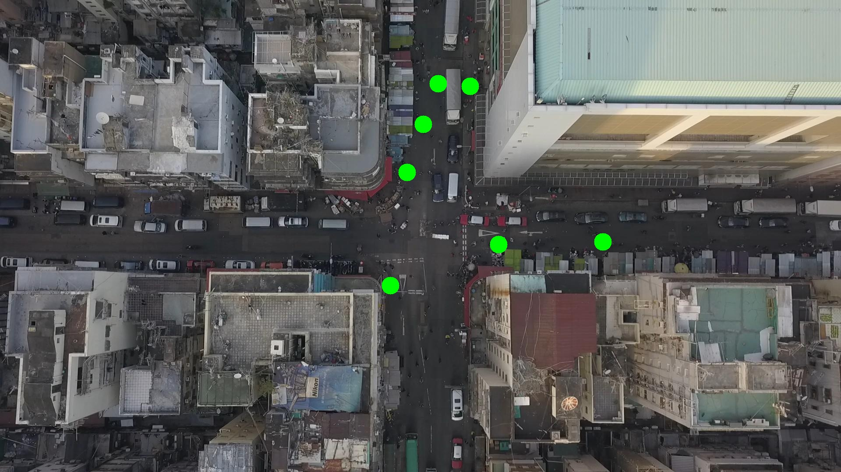

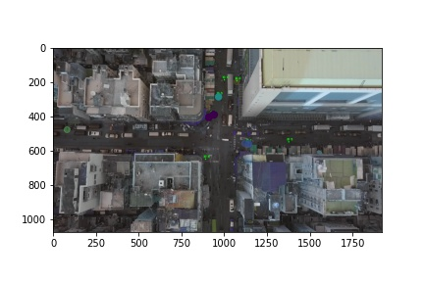

Silhouette metric for img011012.jpg is: 0.9678914701847835

Davies Bouldin metric for img011012.jpg is: 0.037913813209875837

Calinski Harabasz metric for img011012.jpg is: 57175.457942197536

ID 0: (1085, 141)

ID 1: (1132, 560)

ID 2: (938, 389)

ID 3: (966, 283)

ID 4: (1000, 191)

ID 5: (1376, 553)

ID 6: (891, 653)

